**Uber-Case Study**

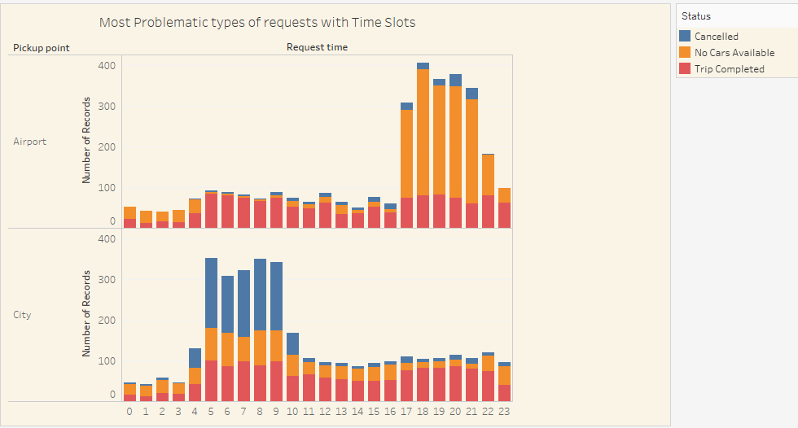

Have prepared Uber -Demand & Supply Gap analysis for cabs in Mumbai City-Airport. This was part of my Study Assignment in IIIT-Bangalore.Data Cleaning is done in R programme and visualization done in Tableau.Data is for 5 days of a month for 24 hours timeline.

Following Data cleaning was performed to clean the inconsistent date format,convert time format into R mode and creation of different time slots.

#Make the time & date separator consistent  
dataset$req_dt <- str_replace_all(dataset$Request.timestamp, “[/]”, “-“)  
dataset$drop_dt <- str_replace_all(dataset$Drop.timestamp, “[/]”, “-“)

# convert time columns to datetime  
dataset$req_dt <- as.POSIXlt(dataset$req_dt, format = “%d-%m-%Y %H:%M”)  
dataset$drop_dt <- as.POSIXlt(dataset$drop_dt, format = “%d-%m-%Y %H:%M”)

#Create a separate hour and day column  
dataset$reqhour <- format(dataset$req_dt, “%H”)  
dataset$day <- format(dataset$req_dt, “%d”)

#make separate Time slots  
dataset$time_slot = ifelse(dataset$reqhour < 5, “Pre_Morning”, ifelse(dataset$reqhour < 10,”Morning_Rush”,ifelse(dataset$reqhour < 17,”Day_Time”,ifelse(dataset$reqhour < 22,”Evening_Rush”,”Late_Night”))))

I have ignored the dates in the below visualization as the status is consistent with each date.Hence only included time.

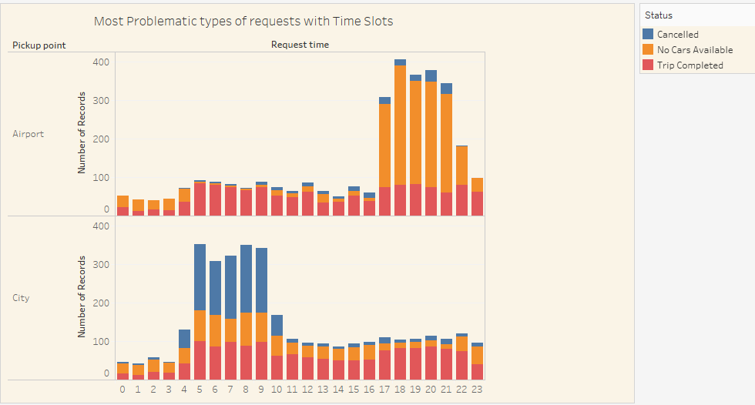

* Cancellation is more from the City compared to cancellation from Airport.
* For City Request: Cancellation is more during the early morning time between 4am to 10 am compared to other time.
* Cars are not available during evening time during from 5pm to 10pm for Airport pick up

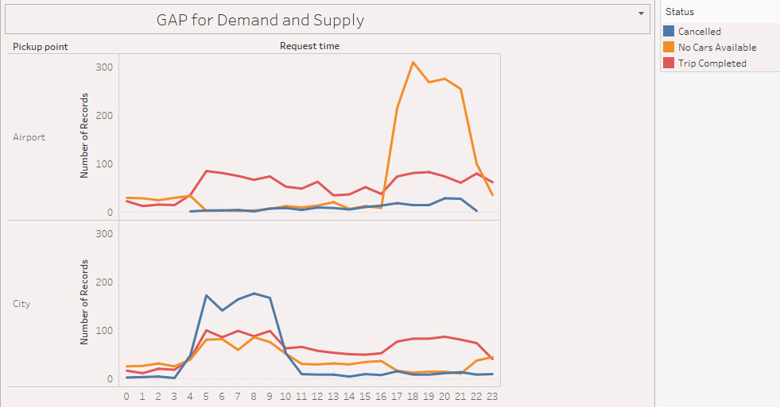

* The average demand for the cars are around from 0 to 100 but it surges to 300 requests during evening time from Airport. There is huge spike in demand for the cars during 4pm to 10pm for Airport pickup but the car available during the same time looks low. This results in huge demand supply gap.
* There is also cancellation from Drivers during the morning hours between 4am to 10am resulting in less supply during the period of time from City.
* The requests from City pick up looks controlled the trip completed are correlated with the cabs available /cancelled expect for early morning wherein cancellation is high.

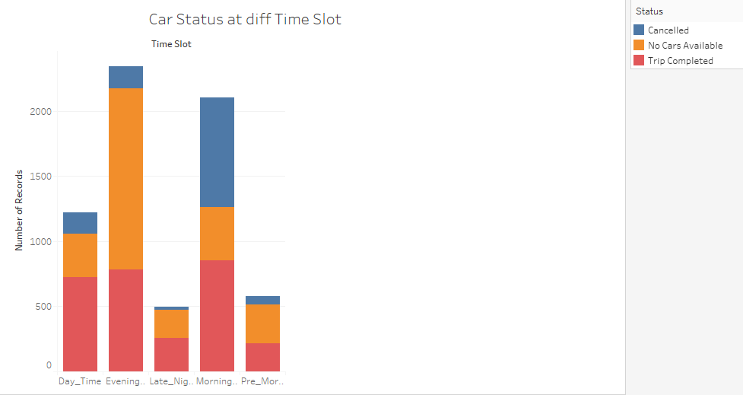

* Overall the cancellation is high during morning hours.
* Cars are not available during evening hours
* There is wide fluctuation in the Proportion of trips completed vs cancelled/no cars available

Conclusion : Following can be the recommendation to improve the issues.Drivers can be given bonus from city to airport to reduce the cancellation. Uber can co-ordinate with airport authority to reduce the idle time. Car pool can be introduced to serve the more number of customers in Rush hours.Impose penalty for cancellation of requests by Driver.Provide base price to comeback to city with empty passengers.